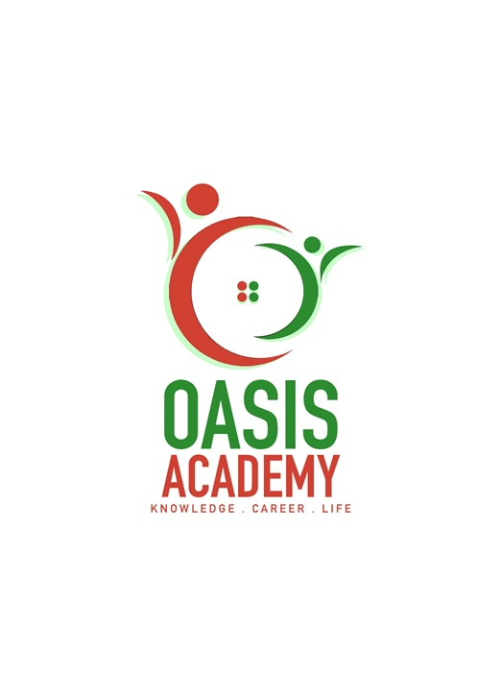

NAME : DARSHNEEPRIYA SANDRA SIGARAN

LOGIN ID : darshneepriya@oasis-portal.com

COURSE TITLE : TOURISM AND HOSPITALITY

SUBJECT CODE : BHM04

SUBMITTED DATE : 11 SEPTEMBER 2017

1

TABLE OF CONTENTS

|  |  |  |
| --- | --- | --- |
| NO | DETAILS | PAGE |
| 1 | EXECUTIVE SUMMARY | 3 |
| 2 | INTRODUCTION | 4-7 |
| 3 | ASSIGNMENT QUESTION |  |
|  | PART 1 | 8-26 |
|  | PART 2 | 27-38 |
|  | PART 3 | 39-53 |
|  | PART 4 | 54-56 |
| 4 | CONCLUSION | 57 |
| 5 | REFERENCES | 58 |
| 6 | APPENDIX | 59 |

2

EXECUTIVE SUMMARYs

Although many of us have been "tourists" at some point in our lives, defining what tourism actually is can be difficult. Tourism is the activities of people traveling to and staying in places outside their usual environment for leisure business or other purposes for not more than one consecutive year.

In this module, I will cover the topic of Tourism and Hospitality and will describe the meaning of Tourism and Hospitality. In the first part of question, we can see the introduction of Tourism and Hospitality and its importance and understanding about hospitality industry. Besides that, i would like to share some information about the tourism system and tourism products. In second part of question, I will describe about the types of tourists and the introduction about tourism and hospitality. Furthermore, in third part of question i would talk about the differences sectors in hospitality with some simple examples. While, i would like to share some different types of accommodation in tourism. Last but not least, i will explain about the Significant of entertainment in industry.

3

INTRODUCTION :

A set of curriculum support package of tourism and hospitality learning and teaching materials is being developed by the Personal, Social and Humanities Education Section of Curriculum Development Institute, Education Bureau for the implementation of the senior secondary Tourism and Hospitality Studies fine-tuned curriculum in schools. The curriculum support package is comprised of five manuals, and they are developed to broaden students’ knowledge of the five different units of the Tourism and Hospitality Studies curriculum.

The content of this manual – Introduction to Tourism, should enhance students’ understanding of the dynamic nature of the tourism and hospitality industry. In addition, the manual includes activities to deepen students’ understanding and help them to apply theories and concepts. Furthermore, student should be able to develop enquiry, problem-solving and decision-making skills through these activities.

The content of this manual – Introduction to Hospitality, should enhance students’ understanding of the dynamic nature of the tourism and hospitality industry. In addition, the manual includes activities to deepen students’ understanding and help them to apply theories and concepts. Furthermore, students should be able to develop enquiry, problem-solving and decision-making skills through these activities.

Tourism embraces nearly all aspects of our society. Apart from its importance to economic changes, human socio-cultural activities and environmental development, tourism is related to other academic subjects such as geography, economics, history, languages, psychology, marketing, business and law, etc. Therefore, it is necessary to integrate a number of subjects to study tourism. For example, subjects such as history and geography help us understand more about the development of the historical and geographical resources of a tourist destination. Besides, subjects like marketing and business help us understand the promotion and marketing of tourism products. The study of information technology enhances our understanding of the importance of the global distribution system and its effect on

tourism business. The study of religion and culture provides information on the cultural resources of a destination and opportunities to develop it as a cultural destination. Tourism is so vast, so complex, and so multifaceted that there is a wide range of subjects related to tourism.

What is the meaning of HOSPITALITY? There have been different definitions of

Hospitality. Broadly speaking, Hospitality is the act of kindness in welcoming and

looking after the basic needs of guests or strangers, mainly in relation to food, drink and

accommodation. A contemporary explanation of Hospitality refers to the relationship

process between a guest and a host. When we talk about the “Hospitality Industry”, we

are referring to the companies or organisations which provide food and/or drink and/or

accommodation to people who are away from home. However, this definition of the

“Hospitality Industry” only satisfies most situations.

4



Figure 1.1 Shows some academic subjects which are related to tourism studies with corresponding examples

5

HISTORY OF TOURISM :

The history of tourism can be divided into 6 different stages as follow:

**1) Roman Empire Period**

During the Roman Empire period (from about 27 BC to AD 476), travel developed for military, trade and

political reasons, as well as for communication of messages from the central government to its distant

territories. Travel was also necessary for the artisans and architects “imported” to design and construct

the great palaces and tombs. In ancient Greece, people traveled to Olympic Games. Both the

participants and spectators required accommodations and food services. Wealthy Romans, in ancient

times, traveled to seaside resorts in Greece and Egypt for sightseeing purpose.

**2) Middle Age Period**

During the Middle Age (from about AD 500 to 1400), there was a growth of travel for religious reasons.

It had become an organized phenomenon for pilgrims to visit their “holy land”, such as Muslims to

Mecca, and Christians to Jerusalem and Rome.

**3) 16th Century**

In the 16th century, the growth in England’s trade and commerce led to the rise of a new type of tourists

- those traveled to broaden their own experience and knowledge.

**4) 17th Century**

In the 17th century, the sons and daughters of the British aristocracy traveled throughout Europe (such

as Italy, Germany and France) for periods of time, usually 2 or 3 years, to improve their knowledge.

This was known as the Grand Tour, which became a necessary part of the training of future

administrators and political leaders.

**5) Industrial Revolution Period**

The Industrial Revolution (from about AD 1750 to 1850) in Europe created the base for mass tourism.

This period turned most people away from basic agriculture into the town / factory and urban way of life.

As a result, there was a rapid growth of the wealth and education level of the middle class, as well as

an increase of leisure time and a demand for holiday tourism activities. At that time, travel for health

became important when the rich and fashionable Europeans began to visit the spa towns (such as Bath

in England and Baden - Baden in Germany) and seaside resorts in England (such as Scarborough,

Margate and Brighton).

**6) 19th to 20th Centuries**

In the 19th and 20th centuries, the social and technological changes have had an immense impact on

tourism. Great advances in science and technology made possible the invention of rapid, safe and

relatively cheap forms of transport: the railways were invented in the 19th century and the passenger

aircraft in the 20th century. World War II (AD 1939-1945) was also the impetus for dramatic

improvements in communication and air transportation, which made travel much easier today than in

earlier times.

6

***-*** *1980s*

The 1980s were called the boom years. Business and leisure travel expanded very rapidly. The

baby-boomers were coming of age and had the money to spend. These travellers were looking for a

variety of tourism products from exciting vacation options such as adventure travel, ecotourism and

luxurious travel.

There was not only a significant expansion in the travel market but also in tourist destinations. The

fall of the Berlin Wall in Germany in 1989 signified the doom of communism in Europe. Countries

such as Russia and the Czech Republic became new tourist destinations both for vacation and

business travellers.

***-*** *1990s*

The Aviation Industry was facing high operational costs, including wage, oil prices, handling fee of

Central Reservation System (CRS), landing charge of the air crafts and advertising fee etc. During

this decade, CRS also marched towards more sophisticated technology. It became possible for

agents to book a huge inventory of tourism products, such as hotels, car rentals, cruises, rail passes,

and theatre tickets from the CRS.

The introduction of “ticketless traveling” (electronic ticket) brings benefits to the airlines by cutting the

amount of paperwork and cost of tickets. At the same time, passengers do not have to worry about

carrying or losing tickets. Although, electronic ticketing does not bypass the travel agents as

intermediaries, it makes it easier for the airline to deal directly with consumers.

The advance in technology also allows the airlines and other travel suppliers to sell directly to

travellers through the Internet and interactive kiosks at airports. The kiosks at the airport usually sell

hotel accommodation, transfer tickets such as bus tickets between airport and downtown areas and

coach tickets from one city to another.

Travellers can now log on to the Internet easily reach for travel information, book a simple ticket or

hotel room through their personal computer at home. There are thousands of new destinations, tour

products and discounted airfares for travellers to choose from.

7

ASSIGNMENT QUESTIONS

QUESTION 1: Define the Tourism and Hospitality ?

: Explain your understanding about Hospitality industry ?

Meaning of Tourism :

Tourism remains one of the top foreign exchange earners of the country, raking in billions of ringgit. As tropical paradise, Malaysia has everything under the sun that appeals to tourists miles and miles of beaches, pristine forests, enchanting island resorts and idyllic rustic scenery. The kaleidoscope of arts, cultures and traditions of Malaysia's multi-ethnic, multi-cultural society coupled with the variety of Malaysian cuisine have always been assets to the tourism industry with better formulated strategics, tourism can become a major money spinner for the nation. The tourism market has yet to be fully tapped. In the first place, viable tourists venues have to be identified and tourism projects have to be implemented after careful and deliberate planning. Projects that are carried out on an hoe basis are not only impractical, but large sums of money would also have to be forked out. Eco-tourism and health tourism are currently gaining popularity and should be given emphasis. The setting up of tourism information centres at all entry points of the country would provide tourists with useful information. Travel agents must be creative and come up with new and interesting packages that would draw tourists. Adopting the same old marketing strategics will be unproductive. The focus has to be shifted. The resounding success of the nation in hosting international events, such as the 16th Commonwealth Games and Formula 1 Racing is proof enough that sports can be an important vehicle in promoting tourism. Tourism promotion missions to foreign countries will help to foreigners to visit Malaysia. Such missions will enable tour and travel agents to sell their tour packages. Travel agents should also study the tastes and preferences of the international clientele and adapt their packages and programmes to cater for them.

The Malaysian public should play its part in keeping the country clean. They should also be helpful and polite to tourists. The media can also contribute to the tourism industry by coming up with interesting articles that will place Malaysia on the world tourists map. With everyone working hand in hand, it will not be impossible for Malaysia to once again emerge as the number one tourists destination in the Asia-Pacific region.

Besides that, Tourism also can be define as the activity of people travelling to and staying in places outside their usual environment for not more than one year for the purpose of leisure, creation or others. Tourism is vital for many countries, due to the income generated by consumption of goods and services by tourists, the taxes leveid on businesses in the tourism industry, the opportunity for employment in the service industries associated with tourism and improve the associated.

8

Key Elements in the Integrated Model of Tourism

1) Travellers

Travellers are at the centre of the model where all tourism activities are focused. Radiating from the

centre are three large bands containing several interdependent groups of tourism participants and

organizations.

2) Tourism Promoters

Tourism promoters are in the first layer, in close contact with the travellers. Organizations in this layer

include tourism boards, direct marketing companies, meeting planners, travel agents and tour operators.

The tourism boards and direct marketing companies provide information and marketing services to

travelers whereas travel agencies, tour operators and meeting planners provide services such as

making travel arrangements and giving professional advice on tourism related matters. All these

organizations usually deal directly with individual travellers

3) Tourism Service Suppliers

Tourism service suppliers, such as airline companies, bus operators, railway corporations, cruise ship

operators, hotels and car rental companies, etc. usually provide services to travellers independently.

The service suppliers may also collaborate to provide tour packages for travellers by combining the

various services such as accommodation, air transportation, theme park entrance ticket, etc.

4) External Environment

All of the participants, either individually or as a group, are constantly responding to a variety of

societal/cultural, political, environmental, economic and technological forces. It is the interaction of

these forces that determine how closely the individuals and organizations work together.

**(i) Societal/Cultural forces**

Such as the local skill and know how, the indigenous cultures of the destination and the

attitude of local people towards the tourists would have a significant impact on the tourist

experience in a destination. One example of encouraging the local community to take part in

tourism is the “Be a Good Host” campaign launched by the Hong Kong Tourism Board. It

aims at enhancing the tourist experience which helps to promote Hong Kong through

“word-of-mouth”.

9

**(ii) Political forces**

Such as government support on infrastructure, its policy on tourism planning, the diplomatic

relations between tourist generating countries and tourist destination countries, etc.

determines the environment of tourism development. For example, because of political

instability in the Middle East, tourism development in the region and the attractiveness of

these countries to tourists has been adversely affected.

**(iii) Environmental forces**

Such as the problems of congestion, pollution, hygienic conditions, loss of green belts

caused by excessive urbanization and development of tourism may destroy the pleasant

ambiance of the destination which visitors look for. For example, Hong Kong’s air pollution

problem as a factor discourages tourists to come to Hong Kong.

**(iv) Economic forces**

Such as the disposable income of tourist and the affordability of a destination affect the

desire to travel. For example, in Hong Kong, due to the economic crisis I 1997, the number

of visitor arrivals in particular from Asia recorded a negative growth in 1998. (Statistical

Review, Hong Kong Tourism Board, 1999). In the recent 2008 global financial crisis, Hong

Kong Tourism Board showed that visitor arrivals in November was 1.1% less than in

November 2007.

**(v) Technological forces**

Such as the popularity of using the Internet for searching information, reservation or

purchasing of tourism products affect the tourists’ buying behaviour. The traditional way of

distributing tourism products through intermediaries, such as travel agents, tour wholesalers

is facing a great challenge. Now that travellers can deal directly with the suppliers, such as

airlines, hotels, operators of attractions to purchase tourism products, they can almost

by-pass travel agents.

10

Careers in the Tourism Sector

**Job Opportunities**

Travel and tourism industry and its’ associated sectors provide various employment opportunities to students. Besides working in travel agencies, airlines, tour operators, theme parks, events and hotels, students can also have other options such as working in government tourism departments, customs services, airline catering, tourism promotions and sales, etc.

The following is a list of some entry positions in the local tourism sector which are available for youngsters to apply.

**Tour and Travel Services Travel and Transportation Lodging Food and Beverage**

- Tour guide - Airline pilot - Receptionist - Waiter / waitress

- Tour escort - Flight attendant - Concierge - Banquet server

- Travel consultant - Ground service staff - Housekeeper - Banquet sales manager

- Incentive travel agent - Air traffic controller - Reservation staff - Chef

- Corporate travel - Cruise crews, etc. - Recreations instructor - Bartender

agent

- Travel academy - Bell attendant, etc. - Cashier

instructor

- Meeting planner, etc.

Table 1.2 – List of Career Opportunities in the Tourism Sector

11

Concepts of ‘Travel’ and ‘Tourism’

‘Travel’ and ‘tourism’ have similarities and differences in their meanings:

**1) Travel**

Travel comprises all journeys from one place to another. It includes all journeys made by people who enter a country for leisure, to work, reside, study or who just pass through a country without stopping.

**2) Tourism**

A brief summary of the definition is as follow:

Tourism means the temporary short-term movement of people to destinations outside the places where they normally live and work, as well as their activities during their stay at these destinations. It should be noted that all tourism should have some travel, but not all travel is tourism. Tourism comprises the activities of persons travelling to and staying in places outside their usual environment for less than a year and whose main purpose of travel is other than the exercise of an activity remunerated from within the place visited. The term “usual environment” is intended to exclude trips within the area of usual residence and frequent and regular trips between the domicile and the workplace and other community trips of a routine character.

12

Meaning of hospitality :

When looking at tourism it’s important to consider the term hospitality. Some define **hospitality** as “the business of helping people to feel welcome and relaxed and to enjoy themselves.”7 Simply put, the **hospitality industry** is the combination of the accommodation and food and beverage groupings, collectively making up the largest segment of the industry.

The pineapple has long been the symbol of hospitality. The Caribs, indigenous people of the Lower Antilles in the Caribbean, first used it as such a symbol. The Spaniards knew they were welcome if a pineapple was placed at the entrance to the village. This symbolism spread across Europe and North America where it became the custom to carve the shape of a pineapple into the columns at the entrance of the plantation.8 Charles Carter added a three and a half foot wooden pineapple to the peak of the roof at Shirley Plantation, the first plantation in Virginia.9

It is now common to see the image of the pineapple as a sign of welcome, warmth and hospitality. The types of employees and resources required to run an accommodation business — whether it be a hotel, motel, or even a campground — are quite similar. All these businesses need staff to check in guests, provide housekeeping, employ maintenance workers, and provide a place for people to sleep. As such, they can be grouped together under the heading of **accommodation and lodging**.

In other meaning of hospitality is refers to the relationship between a guest and a host, wherein the host receives the guest with goodwill, including the reception and entertainment of guest, visitors or strangers.

13

Define of Tourism and Hospitality :

The industry of providing customer service to travelers or strangers. Hospitality professionals generally work in administrative or management positions in a service-based environment, and they are responsible for overseeing the operations and success of an establishment, such as a hotel or restaurant. The hospitality and tourism industry is diverse, and includes many locations including RV parks, food establishments, recreational facilities, campgrounds, boarding houses and youth hostels. While the overall goal of a hospitality professional is to ensure that guests and customers have pleasurable experiences, they can also be responsible for operations, such as hiring and training new staff; supervising office and financial administration; housekeeping, maintenance, and security staff; and marketing.

Hospitality professionals also distribute funds, set room rates, and ensure that the service standards of the business are met. General duties for hospitality professionals vary depending on the size of the business and the amount of staff available. In larger operations, there is usually a hierarchy of general managers, assistant managers, and supervisors who work to perform operational tasks relating to their areas of expertise. In a smaller business, the hospitality professional performs these tasks directly.

Sometimes hospitality professional positions are specialized. For example, some focus on managing the front office, while others can be responsible for convention services or financial administration. If a hospitality professional is employed in a specialized position, he or she must have excellent communication skills and the ability to work well alongside coworkers in other areas of the business.

Employers prefer applicants with a bachelor's degree in business or hotel or hospitality management, but a liberal arts degree along with hospitality experience may also be acceptable. Smaller establishments may accept applicants with a certificate or associate's degree in hotel, hospitality or restaurant management.

14

The importance of hospitality industry :

The hotel sector recorded total revenues in 2005 to be at P36.94 billion, over ten billion higher than the 2003 level (P26.64 billion). Over the years the competition in the hotel sector has kept industry players on their feet for constant service and management innovations as well as service price changes. In fact, lower-end hotels have started to build rapport in competing with high-end ones. One of the business strategies for lower-end establishments is banking on making their service "closer to home". This strategy attempts to capture both tourist and business markets by establishing a homier feel with guest access to living rooms, dining rooms, and kitchens. Some even include home amenities not normally found in high-end hotels such as flat irons, microwave ovens, silverware, and cooking utensils, among others. Other low-end hotels cut costs by employing mostly non-professional helpers. Some are family operated guest houses or lodging places that typically cater to local tourists, often families, who are looking for lower rates, according to IDEA’s Industry Trends.

Furthermore, the same report revealed that “the Hotel and Restaurant Association of the Philippines (HRAP) divides the hotel market into Makati and bay areas. In 2005, HRAP estimates the Makati clientele to comprise around 95% of foreign travelers who aim to conduct business in the country. The bay area clientele is largely comprised of international tourists. Travelers will always be in need of a place to stay. For this reason, the hotel sector heavily relies on tourists, whether foreign or local. The hotel sector thus sees itself vulnerable to the same problems that the tourism industry suffers with: troublesome peace and order situation, environmental and infrastructure degradation, and poor marketing. At the same time, the hotel sector benefits from the peaks of tourism activity: festivals (although seasonal and location-sensitive), spectacles (such as beauty pageants, concerts, and the Papal visit in 1995) and vacation periods (such as during summer and the holidays). With the holidays ahead, tourism prospects may brighten the path for the hospitality industry. Still, even the tourism industry has not been immune to the current global downturn. As tourism activity declines in the wake of the crisis, so will activity in the lower end of the hotel sector, particularly those heavily reliant on local tourism. In the longer run, the industry’s sustained growth depends on how players maintain and improve the quality of service offered to customers. For tourism-sensitive establishments, cooperation with the government and local community is crucial in order to maintain the viability of certain locales as tourist spots. For the industry as a whole, it is worth the investment to improve infrastructure and service facilities. Furthermore, the industry will surely benefit much from a professionalized workforce. Rigorous staff training is necessary if the domestic industry wants to be truly competitive with other countries. Overall, the trends show that the hospitality industry has greatly improved from its state ten years ago. Hotels are constantly investing for refurbishment and facility improvements, especially in the area of information technology and management. Restaurants, particularly chains, likewise improve their production and distribution systems for greater efficiency. In the short run, the industry anticipates a slump in the coming months as an effect of the expected decline in tourism and consumer spending. In the meantime, better quality of services will help sustain the growth of the industry in the long run according to IDEA.

15

# Importance of Tourism Industry :

**1.      Sources of foreign exchange earnings**

Tourism industry is the main influential type of industry in the world. Nepal has also taken tourism industry as its major sector of income in the fiscal year 2009/11.

**2.      Employment Opportunities**

Tourism industry is also one of the influential sectors. It generates employment opportunities. It provides employment to unskilled, semi-skilled and skilled manpower. Guide, load man etc are the personal or labour required in Tourism industry.

**3.      Sources of public as well as private income**

Tourism industry is the source of income for both public also well as private sector government charges tax, sales tax, service tax etc. which is known as government revenue is the income of public. And handicraft, arts etc are the things that attract tourist and most of them buy them and the seller makers some profit which is called private income.

**4.      Cultural Exchange**

Tourism industry facilities cultural exchange tourist carry over various cultural concepts of other countries where they visit. Local people can learn their language, art, skill, culture etc and vice versa.

**5.      Publicity of nation**

Nepal is a small country, difficult to be located in the world map. Tourism helps to publicize the country in different parts in the world. It helps to publicize. Nepalese art, skills tradition, cultural beauty and hospitality to the world.

16

**The tourism system :**

**\*** The tourism system consist of 3 element which are :

a) the people ( tourist )

b) the geographical element

c ) the tourism industry

i) The people ( tourist )

The tourist is the key player in this system. Tourism, in fact, is a human experience, enjoyed, anticipated and recalled by a lot as a historic and/or life time aspect. Therefore, defining the tourist and its classification turns out to be equally relevant.

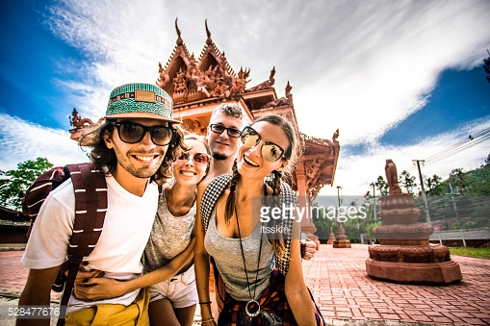

17

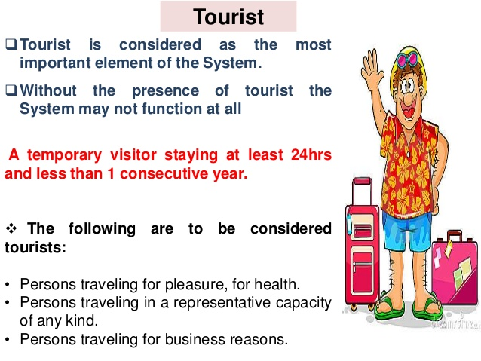

18

ii) The geographical element

Leiper describes three main geographical elements in his system’s model. These are:

i) Traveller-generating region

(ii) Tourist destination region

(iii) Transit route region

The traveller-generating region (TGR) exemplifies the area breeding markets for tourism, and practically acts as the ‘push’ force to motivate and stimulate i.e., set off and encourage travel.

It is this region where the tourist tries to seek information, goes for reservations and makes the departure. This region is basically related to the demand aspect of travel and tourism.

Further, the tourist destination region (TDR) symbolizes the ‘sharp end of tourism’ and is, indeed, the raison d’ etre for tourism. The pull force of the destinations activates the whole tourism system besides begetting demand for travel in the traveller generating region.

According to Leiper, it is at the destination where the most noticeable and dramatic consequences of the system occur. Since, it is the destination where the utmost impact of tourism is felt, therefore, the planning and management strategies are implemented in this region.

Furthermore, the transit route region (TR) typifies not only the in-between places which may be visited en route, but also the short period of travel to get to the destination.

Leiper highlights that ‘there is always an interval in a trip when the traveller feels they have left their home region but have not yet arrived. Where they chose to visit’.

19

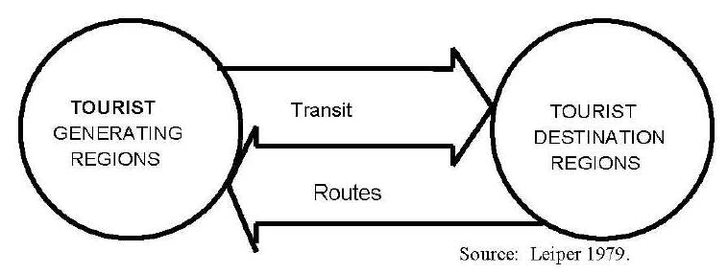

Figure 1: The geographical element

20

iii) The tourism industry

The third element of the model is the tourism industry comprising the variety of businesses and organizations responsible for supplying the tourism product. The model provides for the location of the different industrial sectors to be identified. For instance, the tour operators and the travel agents are primarily set up in the traveller- generating region, attractions and the hospitality business are located in the tourist destination region and the transport industry is largely situated in the transit route region. The operation of the Leiper’s tourism system is such that there is not only an interaction between each element of the system but with other sectors as well so as to deliver the tourism product, to assess the occurrences and impacts of tourism, and the varied backgrounds influencing the occurrence of the tourism activity as represented. An analysis of two major elements of Leiper’s model well illustrates the fact that tourism industry is an industry of noticeably different qualities. Whilst on the one hand, the demand for tourism in the traveller generating region is essentially erratic, inconsistent, seasonal and illogical, the supply is fragmented, unadaptable and rigid in the destination region, on the other. Interestingly, supply is able to match the demand, a sure recourse for the financial fluidity and unpredictability in tourism. Again, the characteristic features of the Leiper’s model can be found in its generalization and lack of sophistication, and these are instrumental in facilitating a practical and effective viewpoint respecting tourism. However, there are other features as well.

i. Leiper’s model is not based or focus on any particular discipline rather makes available a generalized framework capable of incorporating interdisciplinary approaches to tourism.

ii. The model is not a specific one but has a vast scope i.e., tailored to being put to use to any degree or level of generalization, from a local resort to the international industry.

iii. The system’s model also substantiates the basic principle of tourism that there is an interrelationship and interaction amongst the different elements of tourism. Even though, the different elements need to be analyzed individually but these are the interrelationships that provide a perfect comprehension of tourism.

21

It is, by and large, an agreed proposition that tourism comprises of four primary elements – travel demand, tourism intermediaries/agents, destination influences, and the resulting range of impacts. All these elements can be mutually joined in the form of a layout as illustrated. Again, Smith (1981) while describing tourism as a social practice comes up with a thought-provoking but different point of view. According to him, “the phenomenon of tourism occurs only when three elements – temporary leisure + disposable income + travel ethic – occur simultaneously. It is the sanctioning of travel within a culture that converts the use of time and resources into spatial or geographical social mobility. If travel is not deemed culturally appropriate, then time and resources may be channelled elsewhere.” That is, on the one hand, tourism is an accepted industry at the global level, it is also a complex set of social phenomena, on the other. Apart from this viewpoint, falling back on Buck’s hypothesis (1978), tourism can be perceived by means of conflicting and diverse viewpoints: tourism as business vis-a-vis tourism as a set of phenomena. While this highlights the complex and inconsistent approaches adopted by different people, neither approach turns out worthwhile when considered in isolation. Under these conditions, one particularly effective approach can be by way of viewing tourism as a system or set of sub-systems. A gamut of tourism systems with different perspectives but effective in at least some way is produced. The systems approach makes one believe tourism as being related to society and cultural evolution and not simply as an economic activity. A systems approach holds an edge over other approaches in the sense that owing to the nature of systems model being practiced, it is not possible to make out tourism in isolation by chance from its economic, societal, political or natural environments. And here crops up the significance of inter-connectedness between different elements of a system. Given the intricacies and complexities of tourism, the proposition further leads to multi-disciplinary reasoning which becomes all the more crucial to have a thorough understanding of the tourism system. An acquisition of a perception of the tourism system at a particular destination facilitates an extremely fitting understanding of the tourism processes. Thus, getting under way with the framework of integration, including relationships between the tourist receiving region, the destination and the number of tourist generating regions i.e., the system to the operation of the system, the process. Holidaying or leisure tourism is, indeed, extremely involved and complex than just being fun even through it can be contemplated as a system in respect of managing enjoyment and recreation.

22

Tourism has a long-drown-out record of submission and extraction, favoured destinations giving in or submitting to regional high-societies and multi-nationals, so the controversy as regards tourism and its management must be characterized by issues that include tourism impacts on heritage and the way the account of a specific place is described; the prevailing and promising impacts of augmented tourism in congested, populous, multi- communal urban areas/regions where difficulties, strains and stresses may by then exist; the ways and means to isolate tourism from sweeping pulls and leverage, and socio-economic technological phenomena etc. These issues, however, cannot be worked out by means of technological resolutions and advances. Again, management resolves hardly consider the human factor as they, by and large, has a tendency to weigh problems in isolation. Yet again, by and large, have a tendency to weigh problems in isolation. Yet again, it is the people that generate tourism and the ensuing complications, but people cannot be fixed. Thus, tourism being, on the one hand, an interdisciplinary and transdisciplinary field of enquiry, tourism system involves different segments i.e., organizations, businesses and functions, on the other.

Although some of these do not fall directly under tourism sector but have a critical and crucial influence in the overall success of this smokeless fast developing industry. As a result, to have a discerning perception of tourism, it can efficaciously be characterized with the help of a system approach comprising four key elements – market, travel, destination and marketing. The make-up of these four constituents and the type of inter-relationship prevailing between them can be described. Obviously, the resolve to travel and become a tourist can be made out by means of studying the market segment of the tourism system. Once the decision in respect of travel is taken, it leads one to go for another related decision i.e., where, when and how to go. These choices are described and analysed by the second segment of the system i.e., travel. In fact, the choices are influenced by several internal and external pulls such as mode of travels, trends in travel flows, the existing and expected tourism trends. And it brings home the import of the third segment – destination, a blend of tourist attractions, services and facilities/ amenities. The pull of a destination is subject to various market and en route factors with a view to attract, serve and satisfy the tourists. Finally, it is the fourth segment of the system. Tourism marketing, in itself, is a combined, coordinated feat of several types of organizations having direct or indirect linkage to the tourism industry viz., travel trade services, hoteliers, transporters, and other destination based as well as market based public and private sector tourism and non-tourism establishments playing their role. This, in nutshell, is the operation of the tourism system.

23

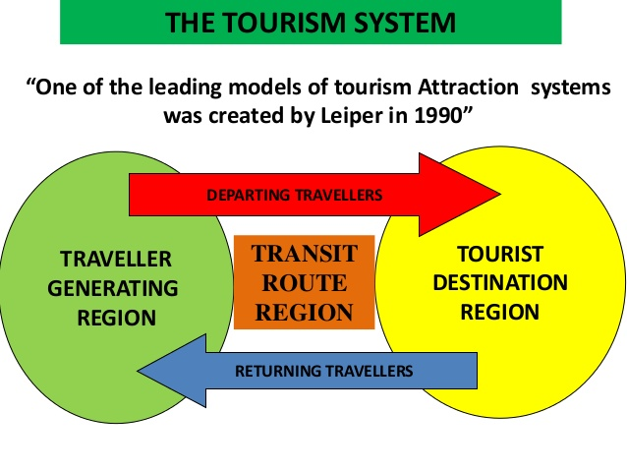

Figure 1 : The tourism system

24

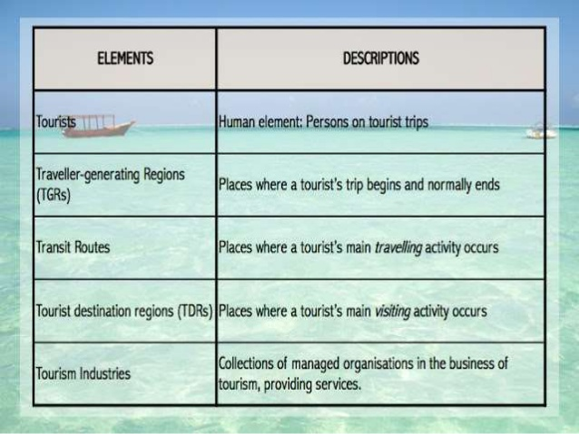

Figure 1 : The tourism industry

25

**Relationship between the Hospitality Industry and Tourism**

As we have seen, the hospitality industry includes hotels and restaurants, as well as many

other types of organisations or institutions that offer food, drink, shelter and other related

services. These products and services are offered not only to people away from home, but

also to local guests. A manager in the hospitality industry, therefore, must keep in mind

the following three objectives:

1. Making the guests feel welcome personally

2. Making things work for the guests

3. Making sure that the operation will continue to provide service and meet its budget

26

ASSIGNMENT QUESTIONS

QUESTION 2: Brief on different types of Tourism categories ?

: Define Tourism ?

Types/Forms of Tourism :-

a) Leisure/ Holiday Tourism:

Tourist may travel to experience a change in climate and place and learn something new, enjoy pleasant scenery, or to know more about the culture of a destination. Tourists, who seek break from the stress of day to day life, devote their holiday to rest and relaxation, refresh themselves. These tourists prefer to stay in some quiet and relaxed destination preferably at a hill resort, beach resort or island resort. Now days, tourists undertake various adventures sports activities for leisure and to refresh themselves after working hard. This tourism includes following forms based on the activities undertaken.

Leisure/Holiday tourism can be divided into 2 forms:

(i) Relaxation

- The destinations for relaxation tourism can be attractive scenery or sun, sea and sand.

Examples of these tourist destinations are the coasts, beaches, countryside and mountainous

regions.

(ii) Sightseeing

- Sightseeing tourism includes the tourists who may travel around sightseeing and staying in

different places. The main reasons for sightseeing tourism are a desire for self-education and for

self-esteem. This kind of tourists take a lot of photographs. Urban centers are their common

destinations, for example, Bangkok, Taipei, Seoul, etc. 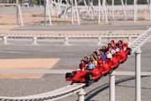

27

b) Cultural Tourism :

Cultural tourism is related to the transmission of knowledge and ideas of the destination area or host community. As tourists are curious about different kinds of experiences and cultures in various parts of the world, they travel to learn and experience the culture of a tourist destination. This becomes the prime motivational force for their travel. This kind of tourist likes to visit different types of cultural attractions, ranging from concrete attractions such as museums and monuments, cultural performances to other cultural manifestations, such as the consumption of the way of life of certain cultures.

It is also called as heritage tourism. People are curious to know about foreign lands and their cultures. Culture is most important factors which attracts tourists to a destination. Cultural tourism gives insight to

- way of life of the people of distant island

- dress, jewelry, dance, music, architecture

- customs and traditions

- fairs and festivals

-religious

-culinary delights

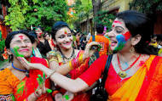 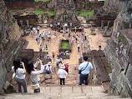

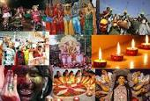 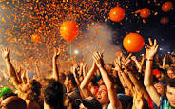

28

c) Religious Tourism :

It is also called as pilgrimage tourism/spiritual tourism. It is a form of tourism, where people travel individually or in group for pilgrimage. The world's largest from mass religious tourism takes place at the annual Hajj pilgrimage in Mecca, Saudi Arabia. Modern religious tourists are most able to visit holy cities around the world. The most famous holy cities are Jerusalem, Mecca and Varanasi.

People are motivated by their religious beliefs. The demand for this kind of tourism is quite stable.

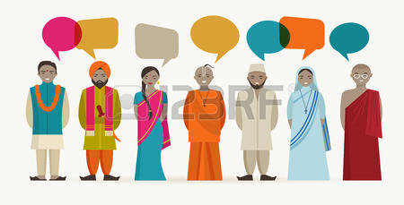

29

d) Family Tourism :

Involves the family unit and their participation in diverse forms of tourism activity. This includes visiting one relatives and friends for interpersonal reasons. Many people in India travel for visiting their friends and relatives. While visiting friends or relatives, people also visit tourists attractions in and around the city.

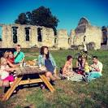 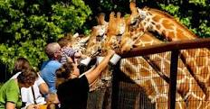

e) Health Tourism :

Is also called as medical tourism. People have been travelling for centuries to improve are rebuild their health and stamina. Today, many people travel great distance to exotic locations or health care facilities in faraway coutries, in search of medical treatment and core. Medical tourism is an age old concept that has gained popularity in the recent times. Many developing countries are emerging as hot medical tourism destinations capitalizing on low cost advantages. Many hospitals have specially designed packages including resorts facilities.

Thus health tourism covers one or more of the following aspects :

- change of climate

- alternative therapy

- medical treatment



30

f) Sports Tourism :

Refers to travel which involves either viewing or participating in a sporting event staying apart from their usual environment. Sport tourism is a fast growing sector of the global travel industry. Sports tourism refers to people travelling to participate in a competitive sport event. Normally these kind of event are the motivators that attract visitors to visit the events like Olympic Games, FIFA World Cup.

Sports tourism can be adventures also. Adventures sport tourism is more challenging because it takes the tourists into regions which are less frequently visited and may not have easy access. According to the National Tour Association, adventure tourism is a ' tourism designed around an adventures activity such as rafting, hiking, or mountain climbing.'

Adventure sports tourism is a package of :

- recreation

-enjoyment

-education

- thrills of participating in an adventure ( land, water, aerial )

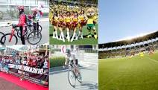

31

f) Educational Tourism :

Educational tourism developed, because of the growing popularity of teaching and learning of knowledge and the enhancing of technical competency outside of the classroom environment. In educational tourism, the main focus of the tour visiting another country to learn about the culture, such as in Student Exchange Programs and study tours, organizing specialized lectures of the eminent personalities and for research.

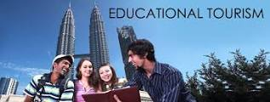

g) Business Tourism :

The business traveler's main motive for travel is work. Tourist visit a particular destination for various reasons pertaining to his/her work such as attending a business meeting, conferences, conventions selling products, meeting clients. Business tourism is popularly called as MICE ( meetings, incentives, conferences, and exhibition ) tourism.

*The characteristics of business tourism are:*

- Business tourists frequently travel to destinations not usually seen as tourist destinations.

Cities such as London, Frankfurt, New York, Tokyo and Hong Kong are important destinations

for the business travelers.

- Business travel is relatively price-inelastic; business people cannot be encouraged to travel

more frequently by the offer of lower prices, nor will an increase in price discourage them from

traveling.

- Business travel is not greatly affected by seasonal factors such as variation in climate or

holidays.

32

- Business tourists take relatively short but frequent trips to major business destinations.

- Business tourists may require different services, such as communication facilities or

secretarial service.

- Business travelers expect, and generally receive, a higher standard of service. For example,

many business travelers would choose first-class or business-class for their flight tickets, and

thus receives higher levels of service from the suppliers, including the travel agencies.

 

h) Alternative forms of tourism :

Alternative tourism aims at seeking a change from impersonal, traditional tourism to establishing cardinal rapport between visitors and the local community. In stead of using tourists commodities these tourists prefer to use or share the services of local people. The focus in these travels is the preserved natural environmental, authentic atmosphere and cuisine, and local traditions. Alternative tourism is now days regarded as a key to sustainable development. It is also known as special interest tourism.

It is of various types:

- eco tourism

- food tourism

- agro- rural tourism

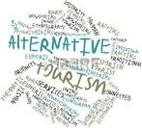

33

i) Visiting Friends and Relatives (VFR) :

Some tourists travel abroad because they want to visit their friends and relatives. It is sometimes said that those visiting their friends or relatives (VFR) are not really tourists at all in the conceptual sense. They do not usually buy accommodation or much food or drink or other services at the destination; but they do consume food and beverages from the supermarkets used by their hosts, and household consumption of other services (e.g. electricity, water) is increased during their stay.

Some of the VFR tourists' destinations may not be tourist attractions, but they are the population

centers where friends or relatives live. Tourists are therefore visiting “non-tourist” areas. In Hong Kong, the popular VFR destinations are the mainland of China, Canada, U.S.A. and Australia.

34

What are the tourism products?

- As tourism is termed as a very big industry, like other industry it also sells its product to the potential tourist. But there is a big difference in the tourism product and other products. As tourism is termed as a smokeless industry and unlike other product it has not its own entity or a single item but it is the combination of different products, services and attractions.

A tourism product is the sum of the physical and psychological experience got by tourist during their traveling to the destination. It is the composite product, as the combination of different services like tourist attraction, transport, accommodation and of entertainment which provide tourist satisfaction.  Each of the components of a tourist product is supplied by individual providers of services like hotel companies, airlines, travel agencies, etc.

The tourist product can be analyzed in terms of its attraction, accessibility and accommodation, activities, amenities and ancillary services.

**a) Attractions:**

- Of the three basic components of a tourist product, attractions are very important. Unless there is an attraction, the tourist will not be motivated to go to a particular place. Attractions are those elements in a product which determine the choice made by particular tourist to visit one particular destination rather than another. The attractions could be cultural, like sites and areas of archaeological interest, historical buildings and monuments, flora and fauna, beach resorts, mountains, national parks or events like trade fairs, exhibitions, arts and music festivals, games, etc. inventory of the various attractions which are of significance in tourism are given below:

**Inventory of Tourist Attractions**

**Cultural**: Sites and areas of archaeological interest, Historical buildings and Monuments, Places of historical significance, Museums, Modern Culture, Political and Educational institutions,

Religious Institutions Traditions: National Festivals, Arts and Handicrafts, Music, Folklore,

Native life and Customs Scenic: National Parks, Wildlife, Flora and Fauna, Beach Resorts, Mountain Resorts.

**Entertainment:** Participation and Viewing sports, Amusement and Recreation Parks Zones and Oceanariums, Cinemas and Theatres, Night Life and Cuisine.

**OTHERS**: Climate, Health resorts or Spas, Unique characteristics not available elsewhere.

 

35

## b)Accessibility:

## *-*It is the means of transport used to reach the area where attractions are located. Tourism mode of transport may be a motor car, a coach, an airplane, a ship or a train which enables the tourist to reach his predetermined destination. Availability of transportation determines the value of the destination, easy accessibility of a place, increase the value of destination or vice versa.

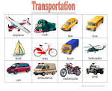 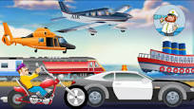

## c) Accommodation:

## - Accommodation plays an important role and very basic to tourist destinations. The demand for accommodation away from home is met by a variety of facilities, which is home away from home. There is a large number of varieties are available in the accommodation. . There has been an increasing demand for more non- traditional and informal types of accommodation. The latest trends in accommodation are holiday villages. In recent years there has been an increase in the popularity of such accommodation.

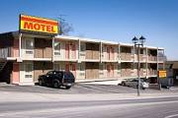 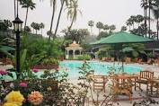

36

**d) Activities**

- The island’s cuisine has been shaped by the people who have made Jamaica their home.  Jamaica has many fine restaurants which offer an array of dining styles in Jamaican, American, Continental, East Indian, Chinese and Italian cuisines, among others. The annual Restaurant Week activities encourage locals and visitors alike to sample offerings at special prices in the island’s most renowned dining establishments .There is a wide variety of festivals and entertainment events year round including community and international festivals. Jamaica’s native music – reggae – is celebrated in many festivals including Reggae Sumfest and Reggae Sunsplash, while the annual Festival of Arts highlights the island’s heritage in music, dance, drama, traditional folk forms and drama. Community festivals are constantly being added to the island’s calendar of events.

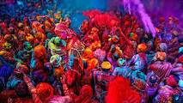 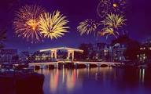

**e) Amenities**

- Tourists also require **amenities** at their accommodation and on the way to destinations and attractions. These can include shops, restaurants, cafes, public transport, tourist information and public toilets.

** **

37

**f ) Ancillary services**

- Ancillary service are services or products that are requested by tourist such as, travel insurance, car hire, transfers to your hotel and also currency exchange. Your travel agent can help you with any of these products, if you require them. Below i have listed the different types of ancillary services provided.

- Firstly Airport hotels provide Fantastic rates at airport hotels, with or without vehicle parking, such as the Bewley's Hotel Manchester Airport. This hotel provides assess to all terminals, and also you are in walking distance to Manchester Airport International. A second ancillary service would be Airport parking, airports offer savings at well under the gate price at most UK airports.

•Car Hire:  
 If you on holiday and you are in need of transport and you prefer car then you can find a nearby car rent. Vehicle rental rates worldwide, including the UK. An example of this would be Euro Car.  
  
 •Transfers:  
Coach, Private Bus, Taxi & Limo, airport to resort transfers, available worldwide. National Express and Abbey Coach Travel ate two examples of a transfer company.  
  
 •Travel Insurance:  
Great rates from one of the UK's premier suppliers. You can get travel insurance from lots of places such as your airline who you fly with such as Ryan Air, your local post office and you can get insurance when you book the holiday from the travel agents.  
  
•Theme Parks:  
All the world major theme parks tickets available at discounted prices. Theme parks such as Alton Towers, Thorpe Park and the Sea Life center.  
  
 •Theater & Concerts:  
London's West End, Broadway & Las Vegas shows, to book in advance of your trip.



38

QUESTION 3: Describe the lodging accommodation and types of Hotel accommodation ?

What is Hospitality in Tourism industry?

- is a bustling industry with myriad categories, but customer service is the unifying factor shared by all segments of the industry.

- For tourism, the hospitality industry is a broad category of fields within service industry that includes lodging, event planning, theme parks, transportation, cruise lines and additional fields within the tourism industry.

Five different sectors of the hospitality industry :

a) **Lodging/ Accommodation**

- this sector of the hospitality industry features a gamut from luxurious hotels to lavish resorts and campgrounds.

- accommodation is an absolutely broad sector of the hospitality industry, ranging from bed/ breakfast enterprise and hotels to other facilities that offer lodging services.

- again, customer services is indispensable in providing accommodation services. And that isnt't all efficiency, integrate comfort, and world class amenities are also its foundation.

i) Lodging :

-When people travel from one place to the other, they need a place to sleep. A shelter which will keep them safe from the atrocities of nature. This results in people booking lodges and rooms for their story.

 

39

ii) Suits :

- Apart from general lodges to stay, hotel sector offers luxury suites for the stay as well. Generally, suites are suitable for formal sorts of staying and are much expensive compared to regular room services.

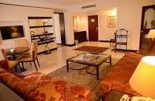 

iii) Resorts :

- The third type of accommodation which is popular among travellers are resort. These bring you close to nature and give you a necessary break from your formal routines.

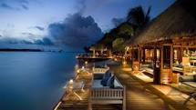 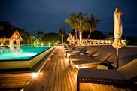

b) **Food and Beverage**

- This is another crucial one among the 5 different sectors of the hospitality industry. It's another wide sector of the hospitality industry. Food and beverage sector reign supreme in the industry.

- It can range from something as simple as a bistro all the way to a high end restaurant and every catering establishment in between.

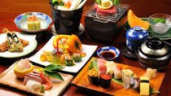 

40

i) Quick Service establishment :

- These are commercial food service restaurants that compete for customers who look to garner quick snacks, drinks and meals.

- Example: MCDonalds, KFC, Subway, Pizza Hut

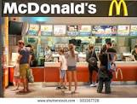 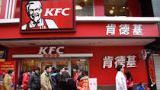

ii) Catering business :

- This category provides food and beverage catering services for any special occasions.

- Examples : Weddings, birthday party

 

iii) Full service restaurants :

-These are your typically restaurants or eateries which features course meals, drinks, and a plentara or other food service. These establishment usually seat you at a table and use waiters to take food orders. From fine dine to casual dining to themed restaurants, there is a range of these full service restaurants.

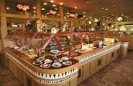 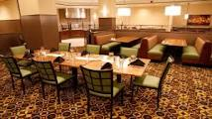

41

*It is also important to discuss the processes and stages involved in food and service industry of hospitality.

1) Food Management

- It starts with the production of food. Many hotels and restaurants serve naturally organic food. Apart from production, food transportation and storage also make part of this division.

2) Food Presentation

- People like to eat food which is well represented. so, a lot of focus should be mode on food representation to improve hospitality experience.

3) Beverages :

- Apart from general food items, beverage storage, and representation also make it into the list of food and catering services.

4) Restaurant Management :

- Is a service which is being taught in colleges these days. With proper skills to manage a restaurant, you can manage food beverages, and maintain a quality representation of food, so that customers will come again to eat at your place.

42

c) **Travel and Tourism**

- A lot consider tourism synonymous to hospitality and not as a different sector of hospitality industry.

- Travel and tourism industry is a vast sector of the hospitality industry with several key players across the globe. Most of them includes trains, airlines, cruise lines, and several crew members in their service.

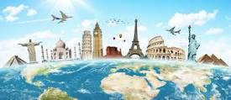



43

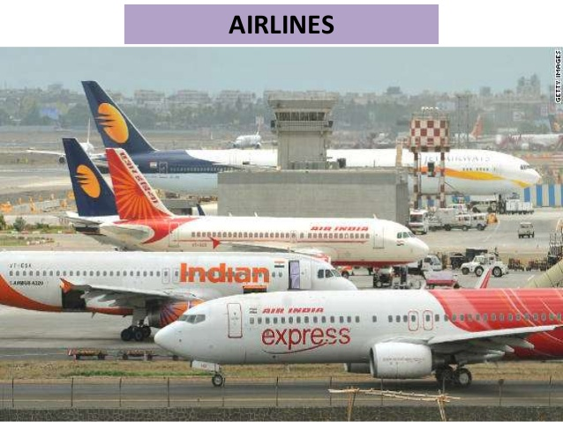

44

d) **Timeshare**

- An emerging yet vastly important sector of the hospitality industry is vacation ownership of a place. In this scheme, people, either individuals or parties, own the rights to a place for a specific time period during the year.



e) **Entertainment Industry**

**-** This again is a key category of the hospitality industry as it involves the most important thing of hospitality. Us, the buyers and receipts of all hospitality services.

45

**Introduction to the Accommodation Sector**

Introduction of the accommodation sector

- There is no generic rule for classifying accommodation establishments globally. One

method is to divide accommodation into two main groups:

􀁺 Non-commercial

􀁺 Commercial

Accommodation

Accommodation

Non- commercial Commercial

Private Hotels

e.g. Private home

Non- profit Service Apartments

e.g. Shelter

Institutional

e.g. University

Figure 1－Accommodation structure

46

**Hotels and Their Classifications**

- As **Hotel** is the predominant type of commercial accommodation in Hong Kong, we,

therefore, will discuss in depth about how hotels can be classified. The Hotel Proprietors Ordinance Chapter 158 provides a clear definition of a hotel: “Hotel” means an establishment held out by the proprietor as offering sleeping accommodation to any person presenting himself who appears able and willing to pay a reasonable sum for the services and facilities provided and who is in a fit state to be received.



Guest room

-A hotel is classified as a commercial establishment providing accommodations, meals

and other guest services. Originally guests had two choices:

• Luxury hotels

• Budget hotels

- In some countries, hotels were built to serve middle-class families and, when the

economy in general boomed and room supply increased; hoteliers then focused on

setting themselves apart by offering specialised accommodation for:

• Conventioneers;

• Business groups; and

• Special weekend events and families.

47

**Types of accommodation :**

1) **City centre hotels**

- These hotels are located within the heart of a city. The type may vary greatly from business, suites, residential, economy, mid-scale to luxury.

*convention*

2) **Suburban hotels**

- Suburban hotels tend to be smaller properties which usually provide full-service, and locate in suburban area.

3) **Airport hotels**

**-** These hotels are designed especially to accommodate air travelers. They offer a mix of facilities and amenities. The majority offer customers transportation to and from the airport.

4) **Highway hotels or Motels**

**-** They are designed for overnight stays for car travelers, often with very basic facilities. The rooms usually have direct access to an open parking lot. They are often smaller than most hotels.

They are located on the outskirts of towns and cities.

5) **Convention hotels**

**-** These hotels can provide a large quantity of rooms. In addition to accommodation, they provide extensive meeting and function space for holding conventions. There are banquet areas within and around the hotel complex. Most of them provide an in-house laundry, a business centre, airport shuttle service, and 24-hour room service. They are often in close proximity to convention centres and other convention hotels.

6) **Commercial hotels**

**-** They are located in downtown areas. They tend to be smaller than convention hotels. Meeting and function space are smaller, and there are fewer banquet areas.

7) **Resort hotels**

**-** These hotels are located in picturesque, sometimes remote settings. Customers travel long distance to resorts. Usually, they tend to stay longer. Resorts typically provide a comprehensive

array of recreational amenities, as well as a variety of food & beverage outlets ranging from informal to fine-dining restaurants.

8) **Spa hotels**

**-** They are located in resort-type settings or as part of city spa hotels. They provide accommodations, spa treatments, programs and cuisine. Programs offered vary widely. They may include relaxation/stress management, fitness, weight management, grief/life change and pilates/yoga. Spas have professional staff that often include dieticians, therapists, masseurs, exercise physiologists, and in some cases, physicians.

48

9) **Casino hotels**

**-** They have gambling operations which are the major revenue centres. They also provide live entertainment. A wide variety of luxury amenities, hotel services including fine and casual dining and shopping centres are typically available on site.

10) **All-suite hotels**

**-**The guest rooms in these hotels are larger than normal hotel rooms, with separate areas for working, sleeping and relaxing. A living area or pariour is typically separated from the bedroom, and some properties offer a kitchen set-up in the rooms. The amenities and services can vary widely. They can be found in various locations such as urban, suburban, or residential.

11) **Boutique hotels**

**-** Boutique hotels differentiate themselves from traditional hotels and motels by providing personalized accommodation and services/facilities. They are sometimes known as "design hotels" or "lifestyle hotels". The price varies greatly. They are very different in their “look and feel” from traditional lodging properties. They are more intimate, and, perhaps, more luxurious,

and stand out as an individual. The amenities vary greatly depending on what the hotel’s environment and theme chosen. For example, a boutique hotel may not offer Wi-Fi Internet, air

conditioning, or cable/pay TV if it is focus on comfort and solitude.

12) **Timeshares or Vacation ownership**

**-** This is a type of shared ownership where a buyer purchases the right to use the property for a portion of each year. In many cases, when the timeshare is purchased, the buyer receives a deed. This indicates that the buyer can use the property each year at the time specified for the number of years based on the deed and the purchase can be handed down to the buyer’s heirs.

13) **Bed and breakfast inns (B&Bs)**

**-** They are usually family-owned. They are private homes whose owner lives on or near the premises and rents out rooms to overnight customers. The paid accommodation typically includes breakfast. A popular term is “B&Bs” (i.e. bed and breakfast provided). The host often provides customers with assistance regarding directions, and information regarding the local area

including sightseeing suggestions. It is usually located in rural areas and villages.

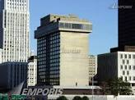 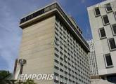

49

**Special Hotels Worldwide :**

- Besides those hotels as mentioned in the previous section, there are also some unusual

hotels which are unique in their features, functions or designs. Below shows some

examples of special hotels located in different countries:

a) Capsule Hotels :

- It is a type of hotel originated in Japan which provides small and ‘bed-only’ cabinets

for its guests. The cabinet size is roughly 2m x 1m x 1.25m and they are mainly

designed for local citizens who look for cheap accommodations when traveling back

to their homes is not an option. Services and facilities are limited, e.g. some may not

have restaurants and guests are required to share the common washrooms inside the

hotel properties.

b) Ice Hotels :

- As expressed in its term, ice hotels are mainly built by using snow and ice. The first

ice hotel is located in Sweden and its concept has been followed by Canada and some

other European countries in building their own ice hotels to attract visitors. Different

from other general hotels, this type of hotel is temporary in its nature which is always

torn down and then rebuilt by artists and designers in different seasons. Due to this

reason, a guest who chooses to stay in an ice hotel in different seasons would find his/

her experience entirely different once the hotel is rebuilt.

c) Underwater Hotels :

- The hotel concepts associating with water have contributed to the development of

innovative hotels with their rooms being built under the water. One example of

underwater hotel can be found in Florida (U.S.) and hotel guests are required to have

a diving certification so they can dive in order to get into their rooms. Some travelers,

who may have negative impression of staying under the water, would prefer choosing

other alternatives, such as floating ones and those which have been built above the

water.

d) Tree House or Treetop Hotels :

- These kinds of hotels are mainly located in countryside, especially in forests. Hotel

rooms are built in harmony with trees which mainly follow the building method of the

native tree houses. The most valuable experience is not provided by the ‘no-gimmick’

in-room facilities but a variety of tours and tourist activities, such as jungle walk,

nightlife animal tours and visiting to native’s houses, etc. Such activities provide

visitors an opportunity to have a closer contact with the natural environment.

Examples of tree house hotels can be found in Costa Rica, Kenya, Brazil and Amazon,

etc.

50

**a) Types of Room Rates**

- The room rate categories have variations in all hotels. Many hotels offer a number of

different room rates to attract different guests who will provide repeat business and

help ensure full occupancy. Examples of different room rates are as follows:

*(i) Rack Rate*

The standard rate charged for the room only.

*(ii) Corporate Rate*

Room rate offered to executive personnel who are regular guests or employees of a

corporation that has a contract rate with the hotel which reflects all businesses from

that corporation.

*(iii) Commercial Rate*

Room rate offered to executive personnel of an enterprise who have infrequent visit.

*(iv) Airline Rate*

The rate agreed between an individual airline and the hotel as determined by the

volume of business the hotel obtains from the airline.

*(v) Group Rate*

Room rate given to bookings for a large group of people made through a travel agent

or professional organisation.

*(vi) Children’s Rate*

Each hotel has a specific age limit for the child to stay with their parents in the same

room free of charge or at a nominal rate.

*(vii) Package rate*

Room rate, which includes goods and services and the rental of a room, is developed

by the hotel to attract guests in during low sales periods.

*(viii) Complimentary rate (Comp)*

Guest is assessed no charge for staying in a hotel. The management of the hotel may

grant comp rooms for guests who are tour directors, local dignitaries, executives from

the hotel’s head office and so on.

51

**Other Related Products and Services**

- It is assumed that a guest who pays a room charge is not only provided with the right

to stay in a guest room but to use other related products and services. Following

shows some common examples of products and services which can be included in the

room rate.

- Wake-up call service;

- Safe deposit box

-Free internet and Wi-Fi access;

- Gymnasium;

- Valet parking;

- Free shuttle service;

- Bell service;

- In-room complimentary food and beverage items (e.g. tea and coffee bags);

- Express check-in service;

- Free access to executive lounge;

- Complimentary newspapers; or

- Welcome drinks at bars or lobby lounge, room cleaning service;

-Turn down service;

-Swimming pool;

**Types of Hotel Guests**

Hotel guests can be classified according to their:

􀁺 Trip purpose – pleasure or business travelers

􀁺 Numbers – independent or group travelers

􀁺 Origin – local or overseas travelers

**1. Leisure Travelers**

They are individuals who travel to engage in leisure activities, outdoor recreation,

relaxation, visiting friends and relatives or attending sports or cultural events.

**2. Corporate Business Travelers**

They are individuals whose frequent bookings are usually made by enterprises with

reduced room rates. Business travelers travel to conduct business, attend business

meetings or workshops, and engage in selling or purchasing products.

52

**3. Free Independent Travelers (FITs)**

They are sometimes referred to as "foreign independent travelers ". FITs are

international tourists who purchase their own accommodation and make their own

travel arrangements.

**4. Group Inclusive Tours (GITs)**

Tourists who travel together on package tours with accommodation and sometimes

meals which are booked through travel agents. Group tourists tend to spend less and

budget their spending allowance.

**5. Domestic Tourists**

They are local residents who stay at a hotel for special occasions and functions.

**6. Conference Participants**

Individuals who travel to attend conference and whose accommodation is usually

reserved by himself/herself, his/her enterprise or a conference organiser before their

arrival.

**7. Very Important Persons (VIPs)**

Very important persons may include celebrities, frequent-stay guests, guests in

expensive rooms, guests with security risks and top executives from enterprises.

**8. Incognito**

They are guests who stay in a hotel with concealing identities so as to avoid notice

and formal attention.

53

QUESTION 4: Explain the Significant of Entertainment in this industry ?

Meaning of entertainment industry?

- is a group of sub-industries devoted to entertainment. Entertainment industry is used to describe the mass media companies that control the distribution and manufacture of mass media entertainment.

What is a sector entertainment in this industry?

- Entertainment is any activity which provides a diversion or permits people to amuse themselves in their leisure time, and may also provide fun, enjoyment and laughter. People may create their own entertainment, such as when they spontaneously invent a game, participate actively in an activity they find entertaining, such as when they play sport as a hobby, or consume an entertainment product passively, such as when they attend a performance.

- The entertainment industry ( informally known as show business or show biz ) is part of the tertiary sector of the economy and includes a large number of sub-industries devoted to entertainment.

Types of entertainment :

a) Exhibition entertainment:-

- art exhibits

-fairs

- museums

-theme parks

b) Live entertainment :-

- circus

-fashion show

-night clubs

54

i) Marinas

- Are one of the most popular places to go when it comes to partying. You can get along with your friends on a private yatch where you can dance, play games and enjoy the best of your life.

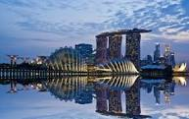 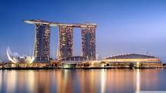

ii) Sports and gaming

- Is a basic thing which people are looking for on their travel.

 

iii) Cruise

- Cruise services also becoming an essential component of the hospitality industry.

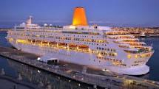 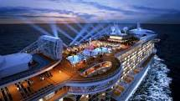

55

iv) Nightclubs

- love to dance

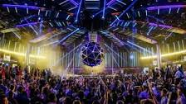

v) Bars

- Sitting around a table and having a couple of drinks with your friends.

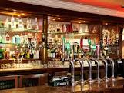 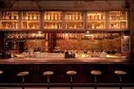

56

CONCLUSION :

Hospitality and tourism industry now days has become one of the large and essential industries that contribute to Malaysian economy. With more and more jobs on offer, hospitality and tourism industry are among the growth industries in the world. The Malaysian Department of statistic has reported that Labor Force Participation Rate ( LFPR) in touring, tourism industry is 7.4 . So, this indicates that workers participation in this industry is quite high and same important with other industry in Malaysia. Hospitality and Tourism industry has grown from the days of the late 80's until 2012. Hospitality is between guest and host and a service that includes in terms of accommodation, restaurants, event planning, casinos, catering, and additional fields within the tourism industry.

Each unit hospitalities like hotel or restaurants has its own management as waiters, receptionist, cleaners and others. However, tourism can be define as the leisure, business purpose and also the recreational time for people that need rest. Hotel industry is booming in Malaysia, especially in places that have an attraction to tourists, such as in coastal areas and historical sites.

57

REFERENCES :

1) Oxford Fajar Sdn Bhd, first published 2014, Author by, Maryann Sebastian, Jayati Roy

2) https://www.slideshare.net/BrendanCarreiro/clipboards/my-clips?rftp=top_clipboards

3) https://www.slideshare.net/SBrooker/tourism-ppt-7748923

4)http://www.esade.edu/cedit2006/pdfs2006/papers/tourism_product_development_dds__esade_3r_may_2006.pdf

5) http://www.depts.ttu.edu/hs/ccfcs/PDFs/Intro_Hospitality_Tourism.pdf

6)http://www.google.com/url?sa=i&rct=j&q=business%20tourism%20pictures&source=images&cd=&cad=rja&uact=8&ved=0ahUKEwjF9OqViPDVAhUJOY8KHWrSDOcQjRwIBw&url=http%3A%2F%2Fwww.traveltoukraine.org%2Fcrimea%2Ftypes-of-tourism.php&psig=AFQjCNEU-9QgRouRvyb8lJR5QNYHo8z2bQ&ust=1503670744315936

7)http://www.google.com/url?sa=i&rct=j&q=sports%20tourism%20pictures&source=images&cd=&cad=rja&uact=8&ved=0ahUKEwjbrIbxh_DVAhXELY8KHSLdA-YQjRwIBw&url=http%3A%2F%2Farticle.japanican.com%2Fen%2Fculture-experience%2Fsports_tourism_2011.html&psig=AFQjCNHzsRfgjgbSGdD1Rz-T9sV2v7N6XQ&ust=1503670667195592

8)http://www.gettyimages.com/photos/tourist?excludenudity=true&sort=mostpopular&mediatype=photography&phrase=tourist#license

9)http://timsmet.com/The%20different%20definitions%20of%20Hospitality%20and%20Tourism%20and%20how%20they%20relate%20to%20economic%20studies%20on%20these%20subjects.pdf

58

APPENDIX



 

59